INVENTION DISCLOSURE FORM FOR PATENTS

Applicant Name-Marwadi University

- Particulars of Inventors

Mr./Ms/Dr. | Name (Full) | Department | Designation | Mobile No. | Email | Postal Address
Mr. | Mihir Malikali Mithani | Information And Communication Technology | Student | 9904146370 | mihir.mithani121063@marwadiuniversity.ac.in | Marwadi University, Rajkot-360001
Ms. | Gouri Unnithan | Information And Communication Technology | Student | 9104611904 | gouri.unnithan122499@marwadiuniversity.ac.in | Marwadi University, Rajkot-360001
Mr. | Chandrasinh Parmar | Information And Communication Technology | Head of Department | 9824416484 | chandrasinh.parmar@marwadieducation.edu.in | Marwadi University, Rajkot-360001
Dr. | Tapan Nahar | Information And Communication Technology | Associate Professor | 9983250843 | tapan.nahar@marwadieducation.edu.in | Marwadi University, Rajkot-360001

- Provide title of the invention: In 100 words or less, please provide an abstract or summary of the invention:
Smart safety and control for LPG stove system :
The system mitigates critical accidents resulting from LPG leakage. It incorporates an authentication mechanism for stove usage, requiring parental or guardian authorization to prevent unsupervised operation by children. Furthermore, the system manages the gas supply to prevent fire hazards from leaks and automatically terminates the supply upon detection of a leak.

- Detail description of the invention:( Answer to all below are required in detail)

  - Problem the invention is solving:
Fire hazards associated with Liquefied Petroleum Gas (LPG) cookstoves.
This system mitigates fire hazards by replacing the traditional LPG gas stove system and is compatible with both LPG cylinders and a central gas supply pipeline.

  - General Utility/application of the invention:
This system can be utilized in household, restaurant, and hotel settings, as well as in small-scale food businesses and factories.

  - Advantages of the invention disclosing about the increased efficiency/efficacy :
The system provides prevention against critical fire accidents, continuous monitoring, and alerting in the event of a leak/unauthorized access.

  - Best way of using the invention as well as possible variants :
The system is to be installed in the kitchen and can be optimized for the automated cooking of various food items.

  - Working of invention along with Drawing, schematics and flow diagrams if required with complete explanations:
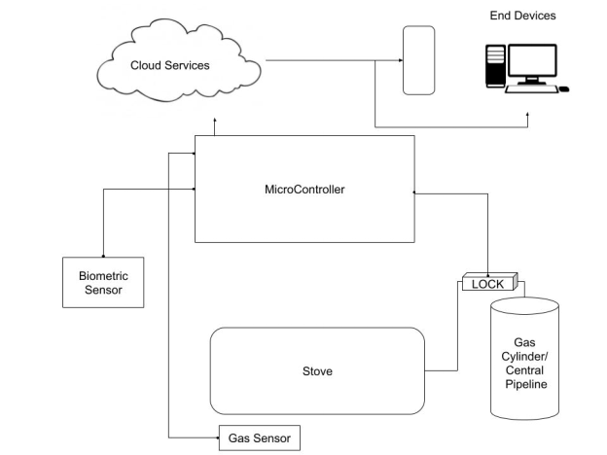

- Have you conducted a Primary Patent Search? Yes / No (if yes, attach the patent search results)

- List out the known ways about how others have tried to solve the same or similar problems? Indicate the disadvantages of these approaches. In addition, please identify any prior art documentation or other material that explains or provides examples of such prior art efforts

S. No. | Existing state of art | Drawbacks in existing state of art | Overcome (how your invention is overcoming the drawback)
 |  |  | .

- List the Technical features and Elements of the invention along with the Description of your invention from start to end.:

- List out the features of your invention which are believed to be new and distinguish them over the closest technology.

- Has the invention been built or tested or implemented? If yes please provide the Efficiency/Efficacy details of the invention

- Briefly state when and how you first conceived this idea?

- Have you sold, offered for sale, publicly used or published anything related to this invention? If yes, please briefly explain the dates and circumstances. List those individuals to whom you have revealed your invention. Were non-discloser documents signed prior to discloser in each case? Please state any deadlines of which you may be aware for filing an application on this invention.

- Include any reasons that your invention would not have been obvious to someone of average skill in the art.

- Additional comments by the inventor (if you want to give more details out of scope of this IDF).

- Drawings/Flowchart/Table



